# 3. Results and discussions

## 3.1 Obtained accuracy of the system

To obtain the accuracy of the model, 5-fold cross-validation method was used. Inside each fold, the training data was normalized inside each feature, and then the model was trained in a training sample and tested on a test sample, which was normalized using the minimum and maximum values of the training sample.

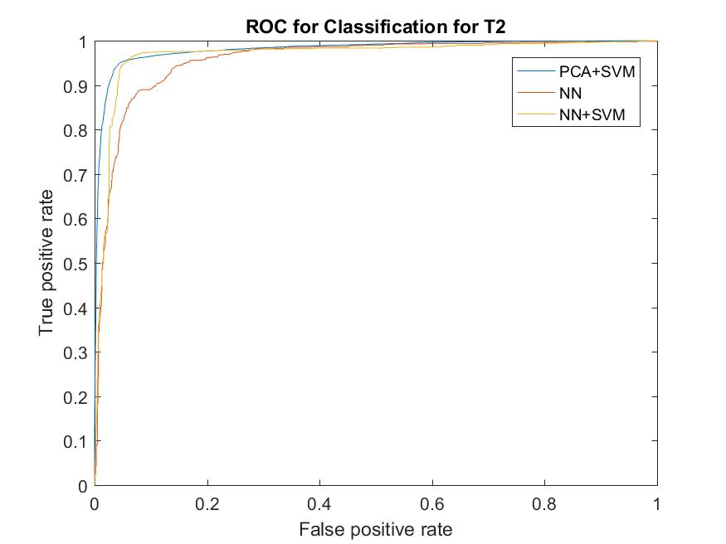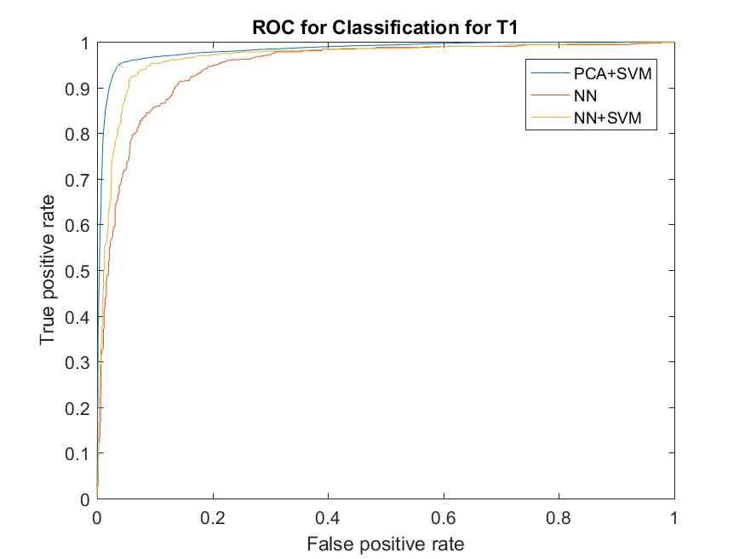Roc-curves of all models are presented at Figure 8-10 for the systems, based on right, left and both fists respectively.

Figure 9: ROC for T2

Figure 7: ROC for T1

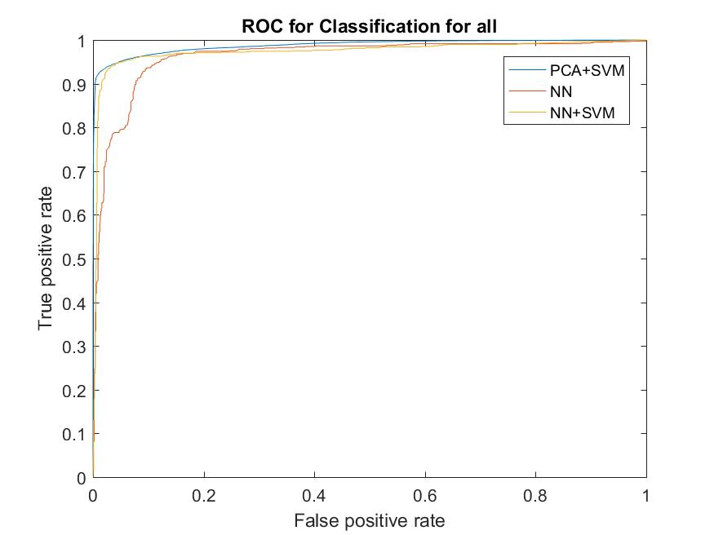

Figure 8: ROC for both

Accuracy, FAR and FRR were calculated for all models and all systems and presented at Table 1-3.

As long as the wrong person should never be authenticated, FAR error is the most important for authentication system, and should be as low as possible.

Table 1: accuracy of NN model

Table 2: accuracy of PCA+SVM model

|  |  |  |  |
| --- | --- | --- | --- |
|  | **Left fist** | **Right fist** | **Both fists** |
| FRR | 0.0242 | 0.0256 | 0.0472 |
| FAR | 0.0166 | 0.0194 | 0.0018 |
| Overall accuracy | 0.9592 | 0.9550 | 0.951 |

|  |  |  |  |
| --- | --- | --- | --- |
|  | **Left fist** | **Right fist** | **Both fists** |
| FRR | 0.133 | 0.1059 | 0.1999 |
| FAR | 0.0899 | 0.0725 | 0.0291 |
| Overall accuracy | 0.8904 | 0.9122 | 0.8931 |

Table 3: accuracy of NN+SVM model

|  |  |  |  |
| --- | --- | --- | --- |
|  | **Left fist** | **Right fist** | **Both fists** |
| FRR | 0.0247 | 0.0162 | 0.0374 |
| FAR | 0.0288 | 0.0227 | 0.0051 |
| Overall accuracy | 0.9465 | 0.9611 | 0.9576 |